CNMI Economic Recovery Plan
Overview
On January 29, 2020 Governor Ralph DLG. Torres issues Executive Order 2020-01, which declared a state of significant emergency regarding the novel corona virus (Covid-19) outbreak. This Executive Order was subsequently amended to outline restrictions on commercial activity throughout the Commonwealth in efforts to contain and mitigate the spread of the disease throughout the community.
Of primary concern to commercial activity were restrictions contained in the Second Amended Executive Order 2020-04 (SAEO 2020-04). The following are the directives provided under SAEO 2020-04 that have restricted economic and commercial activity directly or have indirectly impacted commerce:
SAEO 2020-04 Directive
Directive 10 | Gatherings of more than 10 people in a single room or single space are prohibited at the same time for social, spiritual and recreational activities, including but not limited to, community, civic, public leisure, faith-based, or sporting events, parades, concerts, festivals, fiestas, conventions, fundraisers and similar activities are prohibited throughout the CNMI.
Directive 14 | Facilities open to the general public shall only be open to the public from 6:00 a.m. to 6:00 p.m.
 | Casino, video poker establishments and e-gaming facilities closed
 | Businesses shall also limit the number of customers within their stores at any time to 50% of their permitted occupancy
 | All businesses that offer food or beverages for on premises consumption- including restaurants and bars- must suspend services and may not permit on- premises consumption.
 | All public parks including Mañagaha Island and the Grotto are hereby closed to the public.
 | All public beaches and pathways are closed to all activities except for individual use for purposes of exercise and wellness, both physical and mental, and shoreline subsistence fishing such as talåya and rod and reel, subject to the social distancing requirements of SAEO 2020-04.
 | All businesses engaged in recreational or amusement type activities are hereby closed to the public.
 | Gas stations may be open for the dispensing of gasoline only outside of the curfew hours stated in Directive 16. If the station has a convenience store, then that store may not be open before or after the hours
Directive 16 | No person, adult or minor, shall loiter or be present in, on or about any public streets, highways, roads, alleys, parks, public buildings, places of amusement and entertainment, or vacant lots and places within the islands of Saipan, Tinian and Rota between the hours of 10:00 p.m. and 5:00 a.m.

It is the intention of the Office of the Governor to create a framework for resumption of domestic economic activity in a manner that is cognizant of community concerns regarding Covid-19, administered in a way that ensures protections against further outbreaks in the CNMI, and allows for community participation in mitigating future threats of the disease.
Initial estimates from Centers for Disease Control (CDC) and the Federal Emergency Management Administration (FEMA) originally forecasted the peak infection numbers for the CNMI would occur in May 2020. Due in large part to quick implementation of risk mitigation measures from the CNMI Government and community, the CNMI effectively flattened the peak of this curve, pushing the zenith outward toward June 2020. This approach builds upon this strength of the community and promotes the testing capabilities of the CNMI government to continue to mitigate the spread of this disease while involving the community throughout the totality of the effort.
Proposed Phased Approach
The following approach seeks to utilize the CNMI’s unique ability to mobilize mass testing for the Covid-19 virus and create an implementation plan that accomplishes the following objectives
- Maximizes strong community networks and organizations to promote testing throughout the island
- Enhances situational awareness of the extent of the illness throughout the population
- Provides mechanisms to ensure consumer confidence in the safety of commercial establishments
- Creates a clear and achievable roadmap for the alleviation of restrictions for the community to collaboratively work toward
- Fights stigma against positive and suspected Covid-19 cases and promotes solidarity among the general population
Testing Based Recovery
Using the CNMI’s unique opportunity to perform mass testing for Covid-19 virus, the economic recovery can be predicated on testing benchmarks that will ensure community awareness of the importance of testing, activate community organizations and stakeholders to promote testing, and provide for greater data and knowledge of the CNMI’s state of infection to boost confidence in the domestic economy.
The graduated cumulative testing brackets are designed to allow the alleviation of restrictions provided for in SAEO 2020-04 based on advancing through a COVID-19 Rating system discussed below. Many of the restrictions to be reviewed at the achievement of the respective benchmark should be announced publicly in the early stages of implementation. This will encourage the community to promote testing and collaborate to continue appropriate distancing and hygiene measures to surpass the aggregate volume of negative tests required to alleviate unwanted restrictions.
The activities permitted will be on a spectrum which can be scaled up or scaled back based on the CNMI’s COVID-19 Rating. The CNMI’s COVID-19 rating will be based on testing rates and percentage of test positive over the previous 30 days and calculated daily. Hospital capacity, ICU admissions, mortality due to COVID-19, and regional outbreaks may also factor into rating and decision-making.

Health Metrics

The following formula will be utilized in calculating the COVID-19 rating:
$$\frac{\#Tested}{.20(Population)}+\frac{\#NegativeTests}{.999(\#Tested)}=COVID-19 Rating$$

A sample graphic demonstrating this is provided below.
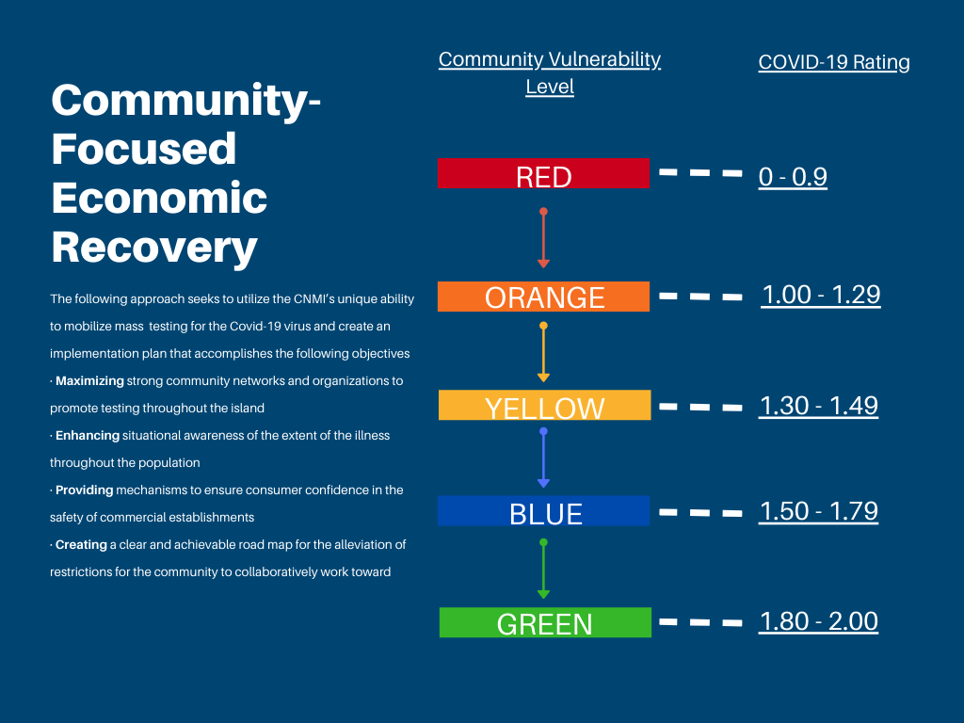

The numbers of tests completed will be aggregated and based upon the testing statistics provided by the Commonwealth Healthcare Corporation (CHCC) and the Covid-19 Task Force. The rating will be calculated by the COVID-19 Task Force, verified by the CHCC, and published on the CNMI Governor’s website. Rating changes will be announced through local news media.
As proposed, this plan envisions total numbers of tests performed being calculated and assessed on a weekly basis. When tourists return, the population value in the formula will include the estimated number of tourists in the CNMI. The number of tests will include any testing performed on incoming travelers, community-based testing, and clinical testing. While some tests may be duplicative (i.e. more than one test performed for the same person), this number is de minimus compared with the total number of tests, so de-duplication of tests is not necessary. If the data showcases two key findings, then the alleviation of restrictions should commence. The findings recommended to be assessed prior to alleviating restrictions are:
- Validity of the testing data – cross checking and validating testing numbers to ensure benchmarks have been achieved. Verification can account for segmentation of individuals who have multiple tests, and those tests performed outside of the community testing initiative.
- Testing Outcomes – Consideration should be given to the number of positive cases for Covid-19 arising from wide-spread testing. Allowance should be given for the Covid-19 Taskforce to delay alleviation of restrictions based on concerns over increasing cases of the disease. The Covid-19 Taskforce should implement a circuit breaker policy that ensures if positive cases exceed an established parameter the phasing ceases and restrictions are reinstituted.
If the two criteria are found to have been met sufficiently, the Governor’s Office may announce the transition of levels, effective the week following announcement.
The proposal places incremental adjustments to restrictions to increase testing and to provide for a gradual phasing of commercial activity. Naturally, full reprieve from restrictions would occur following the expiration of the Governor’s Executive Order and Emergency Declaration.
Detailed Color Classifications
RED
Community Vulnerability Level Red corresponds with a COVID-19 Rating of 0 to 0.9. In this level the CNMI is still in a state of significant concern over the spread of Covid-19 and has reason to remain extremely cautious with regard to restrictions, social distancing, and preventative measures.
- Individuals should remain cautious and continue to wear face masks and practice social distancing at all times when not at home.
- Gatherings of any size of individuals from different households are prohibited.
- Public parks closed, but public walkways and beaches may remain open for individual exercise purposes only.
- Government Offices remain closed.
- Essential businesses only remain open to the public, but are restricted to 6:00am to 6:00pm hours of operation, and shall limit the number of customers within their stores at any time to 25% of their permitted occupancy.
- Bars, casino, video poker establishments, e-gaming facilities, and any other business engaged in recreational or amusement type activities closed
- All businesses that offer food or beverages for on premises consumption- including restaurants- may not permit on- premises consumption, and may only offer take-out or delivery services in accordance with supplemental regulatory guidance from the CHCC - Bureau of Environmental Health.
- Establishments should enforce social distancing precautions and promote the wearing of face masks
- Curfew amended to begin at 10:00pm and end at 5:00am
ORANGE
Community Vulnerability Level Orange corresponds with a COVID-19 Rating between 0.10 and 1.29. In this level the CNMI has made progress toward assessing the full extent of Covid-19 throughout the community, increased outreach on the Community Testing Initiative, and has made progress in streamlining testing and increasing testing efficiency. Orange remains a state of caution for the threat of COVID-19 infections.
- Individuals should remain cautious and continue to wear face masks and practice social distancing at all times when not at home.
- Government Offices open to resume operations with employees that have been tested.
- Essential businesses only remain open to the public, with hours restricted to 5:00am to 9:00pm hours of operation and shall limit occupancy permitted to 50% in accordance with supplemental regulatory guidance from the CHCC - Bureau of Environmental Health
- Establishments should enforce social distancing precautions and promote the wearing of face masks
- Managaha Island open to public with social distancing requirements in place for transport vessels and on-island activities
- Commercial fishing open
- Hotels, tour operators and tourism industry stakeholders should begin preparations for thermal monitoring and establish internal Standard Operating Procedures for mitigating risk in preparation for tourism arrivals alongside Public Health Officials.
- Guidance should be sought to Federal Officials on the steps necessary to resume international flights
- Church Services can commence under strict social distancing guidelines
- Non-contact recreational activities permitted under strict social distancing and sanitation guidelines
YELLOW
Community Vulnerability Level Yellow corresponds with a COVID-19 Rating between 1.30 and 1.49. In this level, testing has become widespread, but efforts to promote testing among community organizations, businesses and households continues. Yellow represents the midway point of phasing schedule and creates the opportunity to assess the levels of positive cases for possible reversion of restrictions if positive cases exceeds previously stated thresholds. If present forecasts for testing remain stable, Yellow would align with the peak number of cases under current FEMA and CDC estimates.
- Individuals should remain cautious and continue to wear face masks and practice social distancing at all times when not at home.
- Partial restaurant service permitted to allow restaurants to serve dine-in customers under strict social distancing parameters and 25% of their originally permitted occupancy limit, in accordance with supplemental regulatory guidance from the CHCC - Bureau of Environmental Health. Restaurants encouraged to use outdoor dining space wherever possible.
- Curfew amended to begin at 11:00pm and end at 5:00am
- Establishments should enforce social distancing precautions and promote the wearing of face masks
- Preparations among tourism operators continue in anticipation of the resumption of flights

BLUE
Community Vulnerability Level Blue corresponds with a COVID-19 Rating between 1.50 and 1.79. In this level, the CNMI is anticipated to be on the tail end of the infection curve but risks a second wave if preventative measures become overly relaxed. Level Blue signifies the progress toward testing approximately half of the island population and the assumption should be held that at this level of testing, increasing numbers of positive cases can be expected. Precautions should be made to ensure thresholds of positive cases are regularly monitored and that immediate action can be taken if positive cases exceed the threshold. Under current testing projections and assumptions on regulatory requirements, Level Blue will correspond with a partial resumption of international flights.
- Individuals should remain cautious and continue to wear face masks and practice social distancing at all times when not at home.
- Building Occupancy restrictions are increased to allow establishments to allow up to 75% of original capacity. Curfew amended to begin at 12:00am and end at 4:00am
- Establishments should enforce social distancing precautions and promote the wearing of face masks
- Partial Restaurant and Bar Service permitted to allow restaurants to serve dine-in customers under strict social distancing parameters and 50% of their originally permitted occupancy limit, in accordance with supplemental regulatory guidance from the CHCC - Bureau of Environmental Health.
- All mitigation measures for the tourism industry should be in place, tested and in line with the requirements of the Covid-19 Task Force requirements to reduce risks upon the resumption of flights.
- Gatherings of people from different households of less than 25 people are permitted throughout the Commonwealth
- Individuals are highly encouraged to remain cautious

GREEN
Community Vulnerability Level Green is the highest phase of this plan and corresponds a COVID-19 Rating between 1.80 and 2.00 or greater. In this level, it is anticipated that more than half of the CNMI resident population has been tested, the levels of positive cases for Covid-19 have not exceeded the thresholds, and partial resumption of tourism flights has not created unnecessary risk to public health and safety. Even at Level Green, restrictions remain in place only until the Governor rescinds the Emergency Declaration for the Commonwealth.
- Individuals should remain cautious and continue to wear face masks and practice social distancing at all times when not at home.
- Restaurant dine-in and Bar service permitted up to 75% occupancy, in accordance with supplemental regulatory guidance from the CHCC - Bureau of Environmental Health.
- Businesses hours restricted to 4:00am to 11:00pm hours of operation
- Establishments should enforce social distancing precautions and promote the wearing of face masks
- Community events permitted under strict social distancing parameters and reduced occupancy
- Gatherings of people from different households of less than 50 people are permitted throughout the Commonwealth
- Individuals are highly encouraged to remain cautious
Guidance and Requirements
Guidance for the safe conduct of many types of activities will be provided, such as rules for indoor and outdoor areas of social interaction, restaurants, bars, schools, and grocery stores.
Gathering Size
- Limit the number of people occupying the facility to ensure all maintain a minimum six-foot distance from one another.
Social distancing
- Mark six-foot increments where lines form.
Operational Activity
- Post signage (state provided) at all entrances of the facility informing all employees and customers that they should:
  - Avoid entering the facility if they have a cough, fever, feeling sick
    - Include contact information for CHCC Info Line for more information
  - Maintain a minimum six-foot distance from one another sneeze and cough into one’s elbow.
  - Do not shake hands or engage in any unnecessary physical contact.
  - Regularly wash their hands with soap and water or use hand sanitizer.
Hygiene and Cleaning
- Encourage use of cloth face coverings to employees and contracted workers whose duties require close contact (within six feet for ten minutes or more) with other employees and/or the public.
- Provide resources and a work environment that promotes personal hygiene such as hand sanitizer, soap and water or effective disinfectant at or near:
  - The entrance of the facility and in other appropriate areas for use by the public and employees
  - Locations where there is high frequency employee interaction with members of the public (e.g. cashiers).
- Restrooms normally open to the public shall remain open to the public.
- Provide hand-washing signage in all restrooms and areas where sink or sanitizer is available.
- Regularly disinfect other high-touch surfaces according to industry standard operating procedures in conjunction with Personal Protective Equipment (PPE) use for staff.
- Develop policies and procedures for prompt identification and isolation of sick staff and customers.
- Employers are strongly encouraged to implement flexible sick leave policies for employees if they have not done so already to encourage employees to stay home if they are sick.
Compliance monitoring and Enforcement
Additional training requirements and certification will be established for those business establishments which want to offer a sit-down option.
Building upon existing Commonwealth Public Law 12-48 “Commonwealth Environmental Health and Sanitation Act of 2000,” Bureau of Environmental Health (BEH) through the Governor’s Task Force and partnership with key agencies (Department of Public Works – Building Code, Bureau of Environmental and Coastal Quality, Department of Commerce – ABTC, Attorney General’s Office – Consumer Protection) will expand these authorities to conduct visual inspection of establishments as part of COVID-19 compliance monitoring. Similar to publishing food safety rating, COVID- 19 regulatory compliance information will be publicly available for residents to make informed decisions.
By implementing monitoring and enforcement, we anticipate that consumer and business confidence will grow and flourish leading to a strong foundation for the return of tourism industry.
Recommendations for Implementation
It is critical that a form of verification is provided to an individual after he or she has been tested negative for Covid-19. In absence of the ability to verify testing status, employers are unable to instill the necessary mitigation measures among their staff to limit the spread throughout the place of employment and to their customers. At the minimum, a letter or signed document attesting to the individual’s receipt of test results would provide for a wider range of options for employers and community mitigation efforts.
Increasing community awareness of the importance of testing will help in ameliorating the fear that persists among many of the test itself and the potential outcomes. Further, if businesses were to encourage their patrons to be tested prior to entering commercial establishments, this would advance testing goals, create greater consumer confidence among those who have been tested, and support the health and wellbeing of employees within the establishment.
Further recommendation would be to make testing for Covid-19 a requirement in areas of concern for economic and community recovery. The test can be added to the requirements for current certification processes, such as the Food Handlers License. Employers are seeking requirements that they may include certification of tests into their regular employment documents – similar in effect to drug testing requirements. Additionally, testing requirements can be included into current vaccination requirements for schools prior to the resumption of enrollment for the upcoming school year.
It is also highly recommended that the government mandate the use of face masks for customers and employees of retail and commercial establishments.
Tourism Resumption and Risk Mitigation
Tourism is both the key to large-scale economic recovery and the source for the greatest increase in overall risk of Covid-19 infection due to the makeup of the CNMI’s tourism market, and the size of the monthly tourism population relative to the domestic population.
While the decision to resume tourism arrivals direct from source countries is complex and requiring a litany of both federal and local restrictions to be lifted, policy on domestic commercial activity can better position the CNMI to mitigate potential risk of infection in the present circumstances.
Entryway Thermal Monitoring
A policy to create a wide-net of Covid-19 symptom monitoring would be to institute a requirement for business establishments and government offices to conduct thermal checks on entrants into the establishments. Hotels, restaurant entranceways are ideal first steps toward implementing a monitoring system that integrates private sector business establishments. Costs should be included into federal grant programs applied for in collaboration with government agencies and nonprofit organizations.
Point of Origin Testing
Allow tourists who possess test results that are negative of Covid-19 prior to board a flight to Saipan and enter the Commonwealth. Test results should be valid within 72 hours or more recent and should be conducted in a manner and methodology accepted by the Covid-19 Task Force.
On Island Testing for Tourists in Quarantine
If feasible with the current total quantity of test kits and the expected future quantity available, tourists who arrive in the CNMI and are subject to momentary quarantine can be allowed to exit quarantine following a test and possessing a negative result.
Establishing Tourism Corridors
As a proposed alternative to a full resumption of tourist arrivals, the CNMI and the private sector can collaborate to establish tourism corridors throughout specific routes throughout the island that will segregate tourists into closely monitored tour groups who will maintain specific routes. These routes should be publicized, and access can be restricted to domestic use. Tour operators and chartered air service will be held accountable for the monitoring and containment of their tourists. This approach will segregate the domestic population from the external risk of tourist arrivals, while permitting economic activity throughout tourism-specific industries and the benefits this activity will provide to domestic employment and tax revenue.
Objectives of this Proposal
The key objective of this proposal is to ensure the health and safety of the CNMI population, while understanding the financial needs of families and employers. The CNMI is unique in the nation in having sufficient testing resources to provide nearly all residents of the islands the ability to be tested. This approach provides greater levels of data to Public Health Officials of the extent of infection throughout the Commonwealth, while recognizing the need for a gradual economic phase-in approach that is based on verifiable data.
This is a Community-Focused Recovery plan that relies upon the community to collaborate toward alleviating restrictions and seeking normalcy in these trying times.

